**Module 2 Lesson #1: Polynomials and Polynomial Functions**

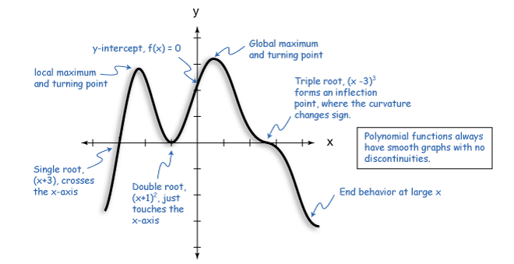

**Learning Targets**

SWUT

The standard form of a polynomial function is $P(x)=a_{n}x^{n}+a_{n-1}x^{n-1}+…+a_{1}x+a_{0}$.

The algebraic form of the polynomial function gives information about its graph and its graph gives information about its algebraic form.

The shape and number of real and imaginary roots of a polynomial is determined by the degree of the polynomial.

The end behavior of the graph of a polynomial is determined by the sign of the leading coefficient and determined by the degree of the polynomial.

Polynomial identities can be used to describe numerical relationships.

Not all polynomials can be described as an even or odd relationship.

Polynomials can be used to model real life relationships.

**What is a *polynomial*?**

1. **The Degree of a Polynomial**

|  |  |  |
| --- | --- | --- |
| **Polynomial** | **Standard Form** | **Degree** |
| 3x3 – x + 5x4 |  |  |
| 3 – 4x5 + 2x2 + 10 |  |  |
| x – 2x2 + 4x3 |  |  |

***Why is the degree of a polynomial important?***

1. **Turning Points of a Polynomial Function (Relative Maximum/Minimum)**

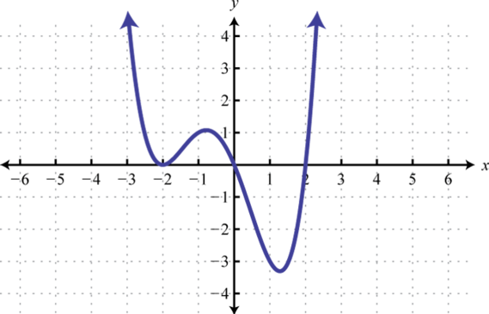

**Example:** Graph $y=x^{4}-8x^{2}$

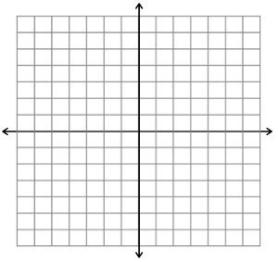

Identify….

Degree of the Polynomial:

Root(s):

Y-intercept:

Relative Minimum(s):

Relative Maximum(s):

1. **The End Behavior of a Polynomial Function with Leading Term axn**

|  |  |  |
| --- | --- | --- |
|  | n is even (n ≠ 0) | n is odd (n ≠ 0) |
| “a” is positive |  |  |
| “a” is negative |  |  |

**Examples:**

1. $y=x^{3}-4x^{2}+4$ 3. $y=-x^{4}+2x^{3}+2x^{2}-x+2$

as $x→∞, f(x)→$ as $x→∞, f(x)→$

as $x→-∞, f(x)→$ as $x→-∞, f(x)→$

1. $f\left(x\right)=-x^{5}+3x^{3}-7x+6$ 4. $f\left(x\right)=2x^{2}-5x-7$

as $x→∞, f(x)→$ as $x→∞, f(x)→$

as $x→-∞, f(x)→$ as $x→-∞, f(x)→$

1. **Even vs. Odd Functions**

Algebraic Approach Graphic Approach

**Examples:**

In the table below, functions $f(x)$ and $g(x)$ are described by their equations and functions $h(x)$ and $k(x)$ are shown by their graphs. Circle whether each function is odd, even or neither. Be prepared to justify both algebraically and graphically.

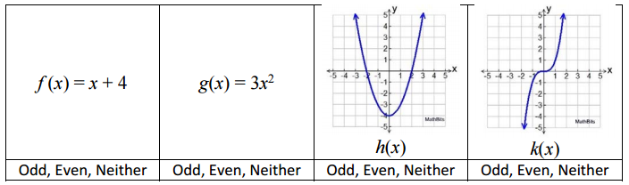

1. **Polynomials in the Real World**
2. The weight, $w$, in pounds, of a patient during a 7 week illness is modeled b the cubic function, $w\left(n\right)=0.1n^{3}-0.6n^{2}+110$, where $n$ represents the number of weeks since the patient became ill.

|  |  |
| --- | --- |
| **n** | **w** |
| 0 |  |
| 1 |  |
| 2 |  |
| 3 |  |
| 4 |  |
| 5 |  |
| 6 |  |
| 7 |  |

1. Sketch a graph of the person’s weight over the course of 7 weeks

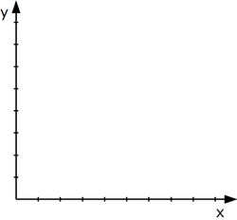

1. What is the least the patient will ever weigh? When did this weight occur?
2. Predict the patient’s weight after 20 week? Does this seem reasonable?